# **PRE-SYNOPSIS**

**Area of work:** Software development and design

**Proposed title**: Counseling and treatment of mental disorders using ML

**Type of approach:** software

**Working Model:** Iterative Waterfall model

**Concept / Idea:** Research based software project which can detect the chances of any mental disorder in a person using different layers and methods.

**Objectives:**

* To make it easier to recognise any mental disorders which can be assessed by their reasoning,lifestyle or any previous medical incidence or trauma.
* Most of the anxiety and depression patients don't want to see a doctor due to social disorders and it can help them to recognise if it is concerning.
* Can be helpful for those who can't reach a doctor or psychiatrists due to their busy lifestyle.
* Can suggest some healthy habits and some changes in lifestyle to reduce the chances of the disease you can be prone to.

**Block Diagram:**

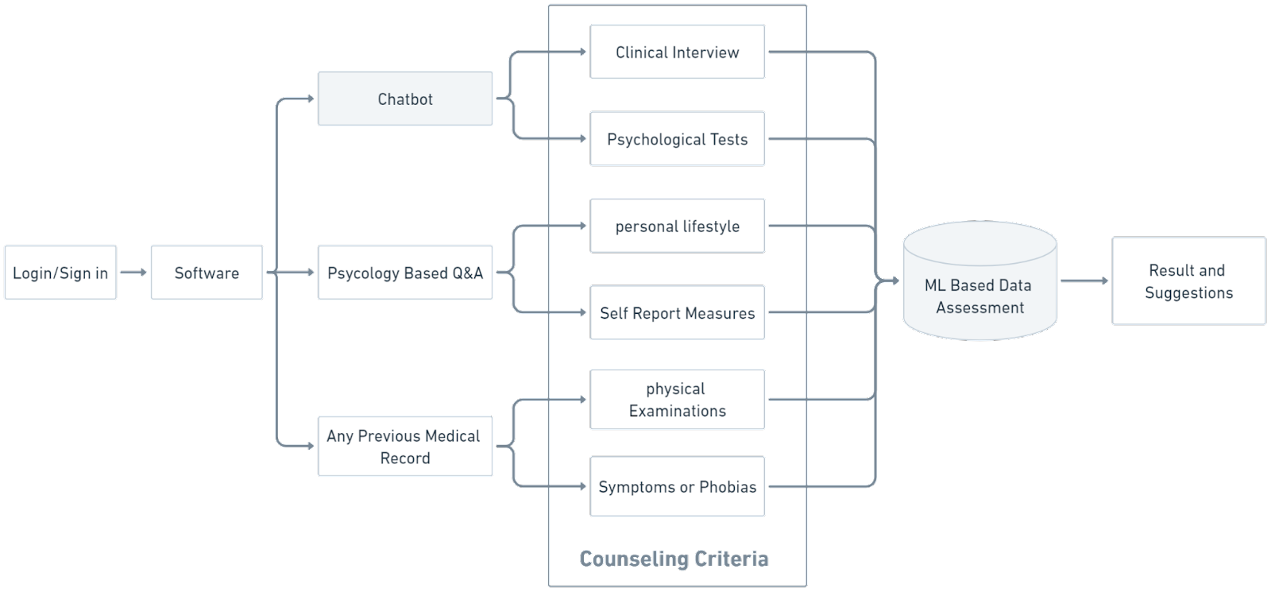

**Name of team members:** Aryan Singh (2001220130025)

Ashutosh Kushwaha(2001220130026)

**Source of Idea -** Self -https://docs.google.com/document/d/1gwzTwz8fczHZVxyzcj8b2WSFVsapcoufos4lyWf0jkM/edit?usp=drivesdk